Screen-Based Trading

User Manual
Increment One

Contents

Logging on to SBT
Overview
Logon Failure
Logging off SBT
Overview
Order Entry
Overview
Enter Limit Order
Undo Enter Limit Order
Display Order Status
Overview
Order Status by Series
Display Book Depth
Overview
Display Book Depth by Series
Display Last Sale
Overview
Display Fill Reports
Overview
Display Best Book Bid Offer (BBBO)
Overview
Cancel Limit Order
Overview
Cancel Limit Order for a Single Series
Undo a Cancel Limit Order
Cancel/Replace Limit Order
Overview
Undo a Cancel/Replace Limit Order

Logging on to SBT

Overview

In order to logon to the SBT system, you must insert your CBOE badge into the workstation badge reader. Your CBOE badge must remain in the badge reader while the workstation is in use. You will be prompted to enter your user ID and password. The password is for the SBT system only. If you change your Windows password (the password that you are prompted for when turning on your machine), your SBT password will remain the same. After verifying that your user ID and password are correct, click on the Login button.

Logon Failure

If your login has failed, verify that your badge is inserted correctly in the badge reader. Confirm your user ID and password and try again. If you are still unable to login, contact systems.

Logging off SBT

Overview

To logoff the SBT system select the Logoff item from the Main menu. Click on File, Logoff. This will prompt you to the Login screen where you have the choice of exiting the system or re-establishing your login. To exit the system click on the Exit button or select File, Logoff from the menu item.

The system will automatically logoff if you remove your CBOE badge from the badge reader on the workstation.

Order Entry

Overview

Once you have successfully logged on to the SBT system, the first window you see is the Market Data window. The Market Data window is one window you will use frequently to navigate through various SBT processes, such as to enter a Limit order.

Enter Limit Order

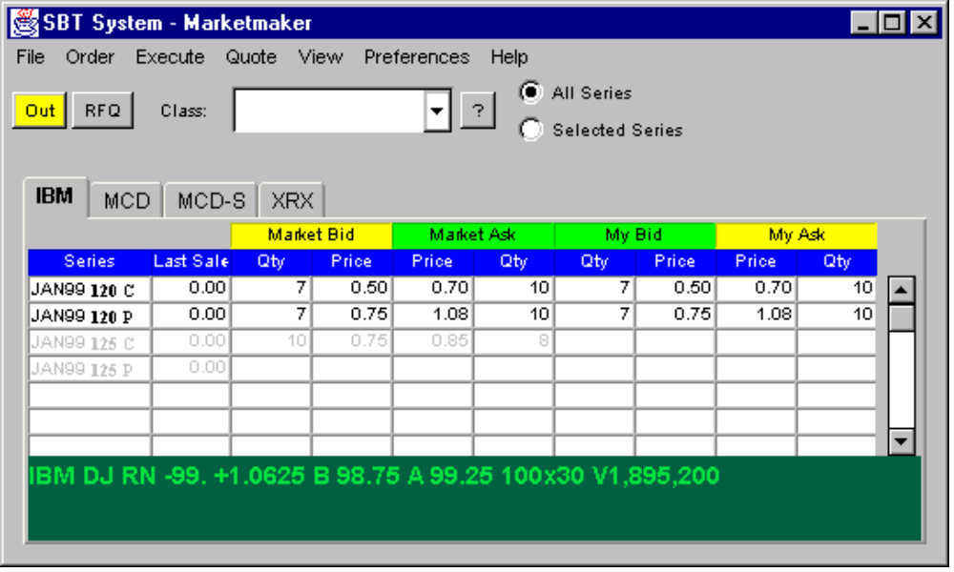

The screen below displays an example of a dialogue for a Limit order entry. You can arrive at this screen in one of two ways from the Market Data window.

- Right-click on a series ID, select Order, Add New Order.
- From the main menu select Order, Add New Order.

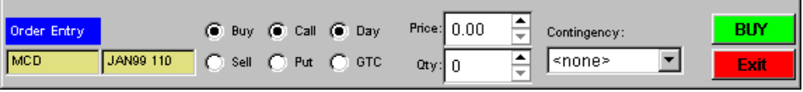

- The dialogue appears pre-set to submit a buy, day order for the selected series. Change the order type to a sell order, a put order or a GTC order by selecting any one of these options.
- Enter the order price either by typing in the price in the price field or by pressing the arrow keys until you reach the desired price.
- Enter the Limit order quantity.
- If there is a contingency on the order, select the contingency type from the drop down contingency list.
- If the order is a BUY order, a BUY button will be displayed. Click on the BUY button to submit the order.
- If the order is a SELL order, a SELL button will be displayed. Click on the SELL button to submit the order.
- A CONFIRM button will appear for you to verify the order. Click on the CONFIRM button to finalize the submission of the order.

Undo Enter Limit Order

To undo a Limit order entry, click on the EXIT button on the Order Entry dialogue any time before confirming the order.

Display Order Status

Overview

The Order Status window allows you to view the status of your working orders.

- Display the Order Status window from the Market Data window by selecting Order, Order Status from the main menu.
- Select to display your orders based on class, active, inactive, buy or sell.
- Click on the Update Display button to view your selections

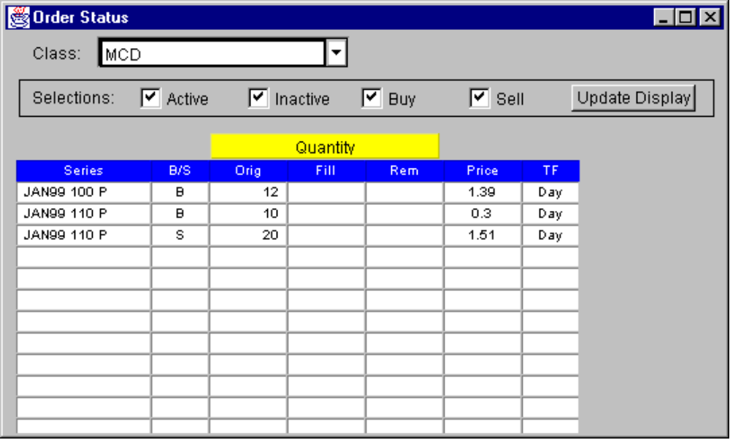

Order Status by Series

You can also view the status of your orders by series.

- Select the series from the Market Data window
- Right-click on the series
- Select Order, Order for Series

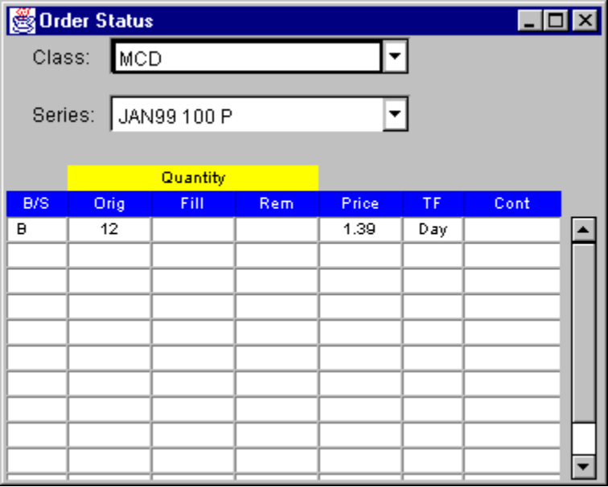

Display Book Depth

Overview

A market-maker has the option to view a Book Depth Display with the summary of the market depth. The screen below is an example of a book depth display for a selected series. You can arrive at this screen from the Market Data window by selecting View, Book Depth from the main menu.

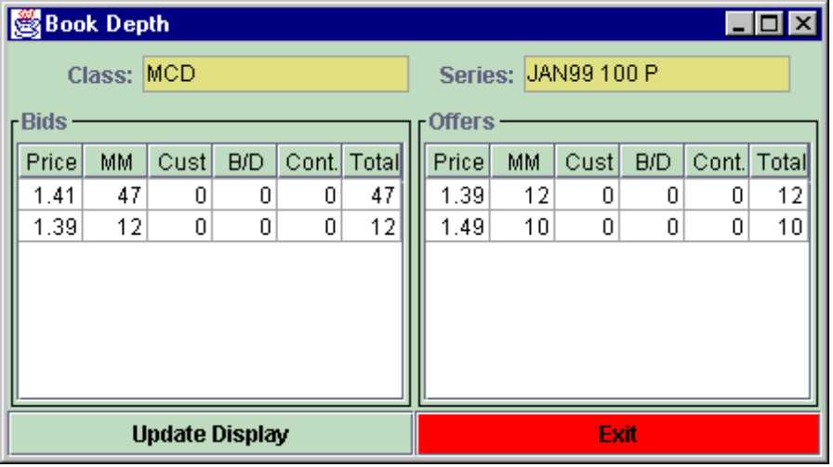

Display Book Depth by Series

You can also display the book depth by series.

- Select the series from the Market Data window.
- Right-click on the series.
- Select View, Book Depth.
- To return to the Market Data window, click on the exit button.

Display Last Sale

Overview

You may request a display of the last sale for a product. The System will update the display in real time as long as the Market Data window remains open.

- Select the classes you want to display on the Market Data window from the Class drop down list.
- A Last Sale column will be displayed with Last Sale information for each class.

Display Fill Reports

Overview

You can view the My Trades Log screen below to display your trades.

- From the Market Data window, select View, My Trades Log from the main menu.
- A display of the all your traded classes will be generated.
- You can select to view your trades for one series or for one class by selecting the class or series from the Class and Series drop down lists.
- Select Exit to return to the Market Data window.

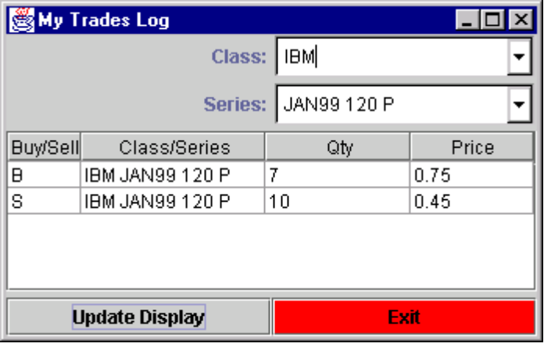

Display Best Book Bid Offer (BBBO)

Overview

You may request a display of the BBBO for a product. The System will update the display in real time as long as the Market Data window remains open.

- Select the classes you want to display on the Market Data window from the Class drop down list.
- The BBBO will be displayed for each class.

Cancel Limit Order

Overview

To cancel a Limit order, you must first display the Order Status window.

- Display the Order Status window.
- Select how you want your orders displayed. They can be displayed based on class, active, inactive, buy or sell.
- Right-click on the order you want to cancel.
- Select the Cancel Order option.
- Verify that it is the order you want to cancel.
- Press the CANCEL button to cancel the order.
- Press the CONFIRM button to finalized the cancel process.

Cancel Limit Order for a Single Series

- Select the order from the Market Data window by right-clicking on the order series.
- Select Order, View Orders for Series. The Order Status (by series) window will appear.
- Right-click on the Limit Order you want to cancel
- Select Cancel Order from the shortcut menu.
- Verify that it is the Limit order you want to cancel.
- Press the CANCEL button.
- Press the CONFIRM button to completed the cancel process.

Undo a Cancel Limit Order

To undo the canceling of a Limit order, click on the EXIT button on the Order Cancel dialogue any time before confirming the order.

Cancel/Replace Limit Order

Overview

The cancel/replace Limit order function enables you to cancel a Limit order and replace it with another otherwise identical order but with a different price or increased quantity.

- Display the Order Status window.
- Select how you want your orders displayed. They can be displayed based on class, active, inactive, buy or sell.
- Right-click on the order you want to cancel/replace.
- Select the Update Order option. An Order Update dialogue will appear.
- Change the price or quantity of the order.
- If the cancel/replace Limit order is a BUY order, a BUY button will be displayed. Click on the BUY button to submit the order.
- If the cancel/replace Limit order is a SELL order, a SELL button will be displayed. Click on the SELL button to submit the order.
- Press the CONFIRM button to finalized the cancel/replace process.

Undo a Cancel/Replace Limit Order

To undo a cancel/replace of a Limit order, click on the EXIT button on the Order Update dialogue any time before confirming the order.

